Principal’s Note
Mark your calendars and lace up your shoes! We are gearing up for our 4th annual Soles for Catholic Education Walk on Saturday, October 15, 2016, at 10:00am at Mount Mary University. We had a blast walking last year. Our fundraising goal is $5,000. We can easily achieve this if every student raises $25.00. The best part is that 100% of all cash and check donations raised for NWCS stays at NWCS and goes toward technology and educational services. Thank you to all the families who have already signed up! There is still time to register; go online to http://www.catholicschoolswalk.org. Registration is FREE through September 19. After September 19, registration is $10.00. Everyone who registers will get a free t-shirt!

Shining together in faith,
Mrs. Paris

Refer a Friend
At NWCS we know the power of you! Help us spread the word about our great school. We want to reward you for inviting friends, neighbors, family, and
co-workers to enroll at NWCS before September 14.

Mandatory NEW Family Covenant Meeting
We are holding a Covenant meeting for all NEW families on Tuesday, September 13, at 2:15pm at the Lower Campus.

If you have not yet attended a Covenant meeting, now is the time. The meeting will last about 30 minutes.






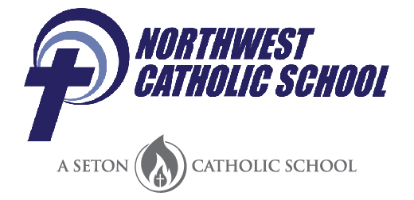
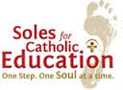
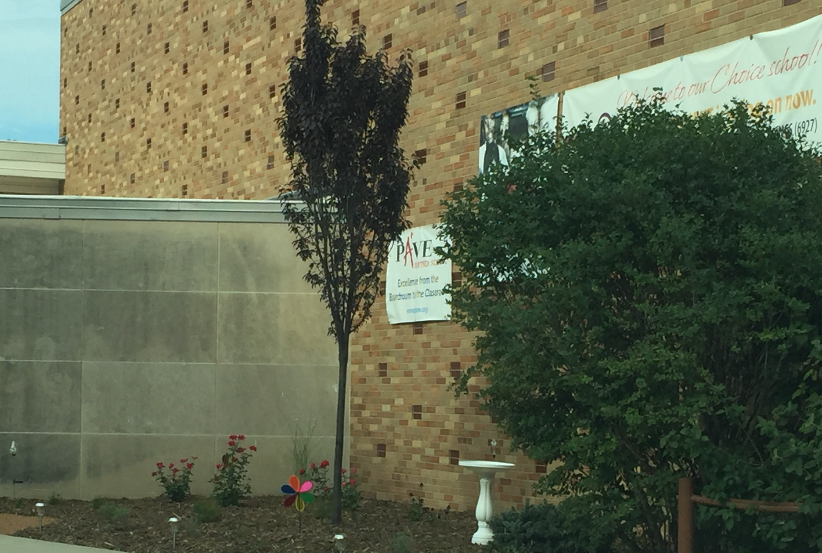

Food
and
Beverage Policy
Food and beverages are only to be consumed in the school cafeteria. This does not include the school-provided fruit and veggie snack.

Chips, candy, cookies, seeds, sports drinks, etc. are only allowed in the cafeteria at lunch. These will be taken away if your student brings them to a classroom. Only water in a plastic bottle is allowed in the classrooms.

This also applies to before and after school care.
ication
Prescription: All medication, in the original
package, must be brought to the school office, labeled with the child’s name and directions for giving the medication. A copy of a doctor’s prescription and a NWCS Medical Consent Form must accompany the medication.
Non-Prescription:
If over-the-counter medication is needed, such as Tylenol or Advil, the medication must be in the original package and brought to the school office labeled with the child’s name and directions for the administering medication.
Winter
Snow and Frigid Temperatures
Are
Here
Please remember that our students
go outside for recess every day,
unless the
temperature,
including wind-chill, is zero or
below.
Be sure your child comes to school
with a winter coat, hat, mittens or gloves, and snow boots.

If children want to play in the snow, they must have snow boots, snow pants, and waterproof mittens or gloves.
Teachers in the Library at Mill Road Library
Teachers are available after
school at selected libraries to
assist students in grades 1
through 8 and their parents with
homework, academic support,
and encouragement. A
responsible adult must
accompany children under 8 years old. Teachers
will help students focus, use appropriate learning
strategies, find the best resources for completing
their homework assignments, and find books
appropriate for their reading level. Teachers will
help parents learn ways to help their children at
home with school assignments by answering
questions they have regarding their children’s
homework.
September 7, 2016
Knightly News
Soles for Catholic Education
The Soles Walk is October 15.
Registration is going on now and forms
must be turned in by Friday,
September 16.
Register by using the form sent home last week or
quickly and easily online at www.catholicschoolswalk.org,
even if you are not sure if you will be at the walk.
Everybody who registers gets a free Soles t-shirt.
Peace Garden Dedication & Back to School Bash
We are excited and proud to announce that our Lower Campus now has a beautiful Peace Garden. Laylah Petersen, a K4 student at NWCS who tragically lost her life nearly two years ago, inspired the garden. Thanks to many generous parishioners and friends of NWCS, the Peace Garden will officially be dedicated on Friday, September 16. We invite all students and families to join us at 6:00pm at
our Lower Campus.

Following the dedication, enjoy pizza and let’s shine together as we celebrate the start of a new school year! An invitation with further details will be sent home next week.
School Pictures
Individual school pictures for grades
K4 – 7 will be taken on Friday,
September 16. (Eighth graders will
have a special picture day later in the
school year.) Students may be out of
uniform this day. All clothing must
be school appropriate – skirts,
shorts, or skorts may be no shorter than four inches
above the knee, no spaghetti straps, no sleeveless tops,
and no shirts with inappropriate words or pictures.

Without education,
you are not going anywhere in this world.
~ Malcolm X

Winter is an etching, spring a watercolor, summer an oil painting, and autumn a mosaic of them all. — Stanley Horowitz

After School Care
NWCS offers after school care for each day school is in session. There is a charge for this service for our school families. The rate is $3.45 per hour for the first child in a family and $2.45 per hour for each additional child in the family.

Billing is done weekly and sent home with the student.
“We rise by lifting others.”
~ Robert Ingersoll
Save the Date
Catholic Schools Week is January 31, 2015 – February 6, 2016. Our school will be celebrating our Catholic identity in many ways during Catholic Schools Week, including a delicious way to kick it off with . . .

NOODLES WITH KNIGHTS
SPAGHETTI DINNER
Thursday, January 28
6:00-7:30pm
Upper Campus Cafeteria/
St. Bernadette Parish Hall

All NWCS families and parishioners from
St. Bernadette, St. Catherine of Alexandria, and Our Lady of Good Hope Parishes are invited. This will be a great opportunity to enjoy a delicious meal and meet our parish members who support our school.
Vacation Bible Camp
NWCS is pleased to announce that we will offer Vacation Bible Camp this summer for students in grades K4 – 4. It will be held July 18 – 22 at Lower Campus.
2016 – 2017 Bus Transportation Reimbursement
Your child/children must be registered at NWCS by June 20, 2016, to be eligible for the MPS bus transportation reimbursement. In addition to being registered by the deadline, you must also live within current MPS transportation boundaries.

If you register after June 20, 2016, you will NOT be eligible for the reimbursement regardless of where you live. For more information please contact Lana Anderson at 414-352-6927, extension 300.

Please note that all decisions regarding reimbursement eligibility are made solely by Milwaukee Public Schools.





St. Bernadette Parish Festival
Mark your calendar for June 19, 20, and 21.

St. Bernadette is holding its annual parish festival. Come for rides, games, food, music, rummage sale, auction, talent show, plant sale, and lots more!
Volunteers Needed
Do you have a few hours a week to help out with our lunch program? Our Lower Campus especially is in need of volunteers. Call Mary Fliss at 414-352-6927, extension 212, for more information.
Medication
If your child needs to take prescription or over-the-counter medication during the school day, you must have a signed Medication Authorization form with the medication, in its original packaging, in the office.
www.facebook.com/nwcschool
* * * IMPORTANT INFORMATION * * *
UPPER CAMPUS Before School
Students should not arrive to school before 7:20am. There is no supervision of students until the school building opens at 7:20. Any student needing to arrive to school at the Upper Campus before 7:20 must check in to the before school care program located on the west side of the building by the playground equipment. Before school care is available each school day beginning at 6:00am. Each student will use the buzzer to the right of the door for entry. Upon entry, the student will enter the daycare room. At 7:20 students will be escorted to the cafeteria for breakfast and to start the school day. Please help us keep our children safe by following this policy.

UPPER CAMPUS After School
All students must remain in areas where there is adequate supervision at all times. The school day at the Upper Campus ends at 3:05pm. Students are to be picked up by 3:15. Any student not picked up by 3:15 will be escorted to after school care located on the west side of the building. After 3:15 parents/guardians will use the door by the playground equipment to pick up their student. Thank you for helping keep our children safe.
Advisory Board Meeting
Our next Advisory Board meeting is being held on Tuesday, May 10, at 6:30pm, in the Upper Campus cafeteria. All are welcome to attend.

NORTHWEST CATHOLIC SCHOOL
A Seton Catholic School
Principal: Michelle Paris

Lower Campus (grades K4 – 4) Upper Campus (grades 5 – 8)
7140 North 41st Street, Milwaukee, WI 53209 8202 West Denver Avenue, Milwaukee, WI 53223
414-352-6927, extension 300 414-352-6927, extension 100

Website: www.nwcschool.org Facebook: www.facebook.com/nwcschool

Respectful, Responsible, Ready to Shine!
Phones at Upper Campus
The Upper Campus experiences telephone issues on occasion: static in our phone lines and at times our phones go down. When this occurs, important calls, like emergencies or health concerns of pupils, can and will be made by the school. The school is able to make outgoing calls.

If you cannot reach the Upper Campus, please call the Lower Campus at 414-352-6927, extension 300. We are continuing to work with our phone vendor to correct the issues with incoming calls.

Thank you in advance for your understanding.
Free Clinic
The Bread of Healing Free Clinic is accepting new patients. The clinic is located at 1821 North
16th Street in the basement of Cross Lutheran Church. It is open to see patients on Monday and Thursday afternoons, Wednesday and Friday mornings, and all day Tuesday. You must call for an appointment.

The clinic serves people who do not have insurance. If you know anyone who needs health care and doesn’t have insurance, please have him or her call 414-977-0001. When you call, be sure to mention that Linda Radder, the Parish Nurse at
St. Bernadette Parish and Cross Lutheran Church, referred you. If you have any questions, please call Linda at 414-358-4600, extension 158.
Uniform Information
With warmer temperatures finally arriving, please be sure to follow the uniform guidelines in the NWCS Family/Student Handbook.

As a reminder, navy blue twill, uniform-style shorts may be worn by all students. Shorts may be no shorter than four inches above the knee. Shorts must be fastened securely at the waist. If shorts cannot be worn securely at the waist, a belt must be worn. Cargo shorts are not permitted. 7th and 8th grade students have the option of wearing khaki twill, uniform-style shorts, skirts, or skorts.

All jumpers, skirts, and skorts must be of the appropriate size and be worn at the waist. They must be no shorter than four inches above the knee. 7th and 8th grade girls have the option of wearing khaki twill, uniform-style skirts and skorts.

Socks or tights are required at all times and must be solid navy blue, red, black, or white.
SEPTEMBER
9/13 Mandatory Parent Covenant Meeting for
NEW families
2:15pm
Lower Campus

Advisory Board Meeting
6:00pm
Our Lady of Good Hope

9/14 Mass/Prayer Service
9:00am
Both campuses

9/16 Picture Day

Welcome Back Bash
6:00 – 7:30pm
Lower Campus

St. Bernadette Fish Fry
4:00 – 7:30pm

9/21 Mass/Prayer Service
9:00am
Both campuses

9/28 Mass/Prayer Service
9:00am
Both campuses

9/29 Building on Books Workshop
3:15pm
Lower Campus

Safe Environment Training Class
6:00 – 9:00pm
Upper Campus Cafeteria

Advisory Board Meeting
Our Advisory Board meeting is being held on Tuesday, September 13, at 6:00pm at Our Lady of Good Hope Parish.

All are welcome to attend.

