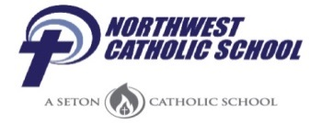Breakfast Menu

April 2017 (All breakfast includes your choice of skim or 1% white milk)
Monday | Tuesday | Wednesday | Thursday | Friday
3  Cereal  String Cheese  Fruit Cup  Juice | 4  Sausage Biscuit Sandwich  String Cheese  Fruit Cup  Juice | 5  No School  Teacher In-service | 6  Mini Waffles  Yogurt  Orange  Craisins | 7  Scrambled Eggs  Toast  Hashbrown  Apple Slices
10  Cereal  Yogurt  Fruit Cup  Juice | 11  Breakfast Stick  Fruit Cup  Juice | 12  Bagel w/Cream Cheese  Fruit Cup  Juice | 13  No Lunch  Dismissal 11:30  All School Day  Lower Campus | 14  No School  Easter Break
17  Have a Happy and Blessed Easter | 18 | 19 | 20 | 21
24  Cereal  String Cheese  Fruit Cup  Juice | 25  Egg & Cheese Croissants  Hash Brown  Apple Slices | 26  Breakfast Round  String Cheese  Fruit Cup  Juice | 27  French Toast Sticks  Sausage Patty  Fruit Cup  Raisins | 28  Scrambled Eggs with Ham & Cheese  Toast  Orange  Juice

Northwest Catholic offers a free breakfast to all enrolled students.
USDA is an equal opportunity provider and employer.

