

**School Hour Changes**

Please note the following times changes:

* Before School Care … 6-7:20am
* Breakfast (in classrooms) … 7:20-7:45am
* Tardy Bell … 7:45am
* Dismissal … 3:20pm

New TARDY and DISMISSAL procedures will be distributed at Meet and Greet.

Dear Parents/Guardians,

I am extremely excited to have all Northwest Catholic Knights ***under one roof!*** Painting, cleaning, and organizing have been the norm this summer as we have prepared for the opening school day on Monday, August 28. We hope you are as excited and ready for school to begin as we are.

The word is certainly out that NWC ***Shines Together*** in loving and teaching our children. Our school continues to grow and expand to meet the needs of our community. We are humbled by the number of wonderful families who choose to become a part of ours. We still have a few openings in several of our grade levels –if you know of someone looking for a school, suggest Northwest Catholic School as an option.

Meet and Greet is Thursday, August 17 from 1pm-7pm. This is a chance for you meet teachers and enjoy dinner on us! Also, if all Back-to-School forms are completed and turned in that same day, your child(ren) will receive a Spiritwear T-shirt!

Looking forward to seeing everyone in a few weeks!



Summer Blessings,

Mrs. Paris

*Please note new school hours

7:45am - 3:20pm

Students must be in their classrooms at 7:45am

or they will be marked tardy!

Breakfast will be served 7:30 - 7:45am

***Back to School***

***Cook Out***

***Meet & Greet***

***Join us on***

***Thursday, August 17!***

***Stop by anytime between 1:00 – 7:00pm.***

Enjoy tasty food

Meet your teacher

Drop of supplies

Have your school picture taken

Complete and Turn-in all Back-to-School Forms and receive a

FREE Spiritwear T-shirt

Calendar of Events

***August***

August 17…… Back to School Cookout /Meet & Greet

Anytime between 1:00 – 7:00p

August 28…… First Day of School

***September***

September 4…… ***NO SCHOOL*** - Labor Day

September 7…… Welcome Back Bash

September 29…. ***NOON DISMISSAL*** -- Lunch will beserved

***October***

October 13…… ***NO SCHOOL***- Teacher In-Service

October 21…… Soles Walk

October 26…… Family Fun Night

**Northwest Catholic Mission Statement**

Northwest Catholic School serves a diverse urban community through strong academics and service rooted in the Catholic tradition. We form productive citizens who live the message of Jesus Christ.

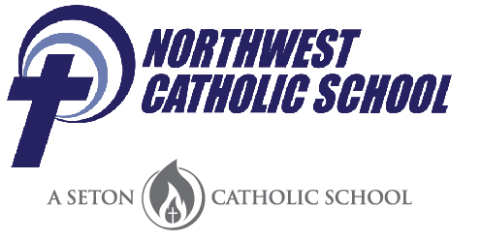

***July, 2017***

*Respectful, Responsible, Ready to Shine*

*KNIGHTLY NEWS*